
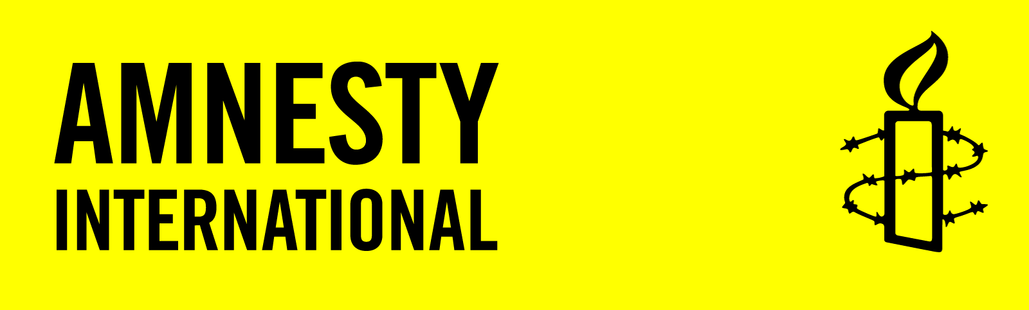

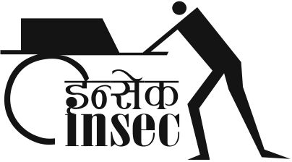

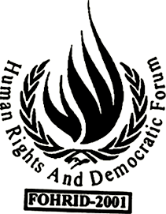
FOHRID

‘Nepal descending towards full-spectrum impunity for human rights abuses committed during the conflict’

Open Letter to: The Government and political leaders of Nepal on the occasion of International Human Rights Day 2010.

From: Advocacy Forum (AF), Amnesty International (AI), Human Rights and Democratic Forum (FOHRID), Human Rights and Peace Society (HURPES), Informal Sector Service Centre (INSEC) and the International Commission of Jurist (ICJ).

10 December 2010

On the occasion of International Human Rights Day, the undersigned Nepalese and international human rights organizations call on the government and political leaders of Nepal to honour the important commitments they have made to address human rights abuses committed during the country’s ten-year conflict (1996-2006), including in the Comprehensive Peace Agreement (CPA) of 21 November 2006.

The abuses committed during this period, many of which constitute crimes under international law, include widespread and systematic incidents of torture and other ill-treatment, unlawful killings and enforced disappearances.

In advance of the Universal Periodic Review (UPR) of Nepal’s human rights record, scheduled for January 2011 at the UN Human Rights Council in Geneva, we urge the government to take immediate, concrete and effective measures to deliver justice and accountability and thereby reverse the country’s descent towards ‘full-spectrum’ impunity.

There are few facets of the justice system in Nepal that have not been subverted to shield perpetrators of human rights abuses from prosecution. Typical practices include political pressure on police to prevent them from registering cases, collecting evidence and apprehending suspects, failure by the executive branch and the military to comply with court orders, and agreements between political parties to withdraw criminal charges in hundreds of human rights case.

Frequent calls for action to end impunity, both from within and outside of Nepal, have failed to yield concrete results. Survivors and the families of victims are kept in a state of intolerable limbo. The failure to address ongoing impunity violates people’s rights to truth, justice, remedy and reparations. It is also causing long-term damage to the rule of law in the country.

Nepal has clear obligations under international law to conduct effective investigations into human rights abuses where those abuses constitute crimes and there is sufficient evidence to prosecute the suspects. However, the police in Nepal have failed to do so in nearly all cases, including in instances of unlawful killings and enforced disappearance by state security forces or former Unified Communist Party of Nepal (Maoist) combatants.

- When five young men in Danusha were killed in October 2003, family members and human rights activists had to make extraordinary efforts to get the police to register the case, as the law requires of them. Police knew about the murders in 2003, but no ‘First Information Report’ (FIR) was registered until 2006. Although the police now claim to be investigating the killings, there is little evidence to support this despite an exhumation of the remains of four men in September 2010. Instead, no charges have been made against any of the accused and there is very credible evidence that relatives have been threatened in order to get them to withdraw the case. It is now seven years since the crime was committed, yet police have not even questioned key witnesses or suspects, which include high ranking personnel in the police and Nepal Army.

Nepal’s leaders made a commitment to investigate and reveal the fate of those subject to enforced disappearances and abduction during the conflict within 60 days of the signing of the CPA in 2006. In addition, a Supreme Court ruling on 1 June 2007, amongst other recommendations, ordered the government to establish a high-level commission of inquiry on disappearances to facilitate Nepal’s compliance with international law and standards. It is now over four years since the signing of the CPA and three and a half years since the Supreme Court ruling, yet victims’ families are no closer to learning the truth.

Progress towards the establishment of a Commission of Inquiry into Disappearances, as well as a Truth and Reconciliation Commission that would look at a broader set of abuses and their causes, have been unreasonably slow. Bills for both commissions continue to include provisions that are incompatible with international law and standards, including provisions for amnesty, statutes of limitations and insufficient guarantees of impartiality of the commissions’ members. In addition, there is concern that these two mechanisms are being viewed by some officials in law enforcement agencies as an alternative to individual prosecutions. Police personnel openly say that they have been instructed by government officials not to proceed with investigations of enforced disappearances and extra-judicial killings; and members of government, including the current Prime Minister, have affirmed in public that the commissions are sufficient to deal with these issues. Although the commissions are welcome, it is essential that they complement, not replace, individual investigations through the normal criminal justice process.

Despite several welcome court rulings on cases of human rights abuses from the conflict, the fact remains that many have not been implemented.

- In September 2009, the Kavre District Court ordered the arrest of suspects in the murder of 15-year-old Maina Sunuwar in 2004. The Nepal Army (NA) openly defied the court order. When one of the suspects, Major Niranjan Basnet, was returned by the United Nations (UN) from peacekeeping duties in Chad in December 2009, the NA refused to hand him over to the police. In June 2010 the NA announced that a military inquiry, that was neither independent nor impartial, and conducted its proceedings in secret, had found him innocent of the charges. The crimes of which Major Basnet is accused, which were allegedly committed against a civilian, must be tried by a civilian court. Under international standards, crimes consisting of serious human rights violations, such as enforced disappearance, should not be tried in military courts. The government’s failure to assert civilian control for such serious human rights violations appears to send a message that army personnel are immune from prosecution for crimes committed during the conflict.

- The investigation into the killing of Arjun Lama by Unified Communist Party of Nepal – Maoist (UCPN-M) cadres in April 2005 has equally been obstructed. Responding to a petition on 10 March 2008 the Supreme Court issued an order to the District Police Office and District Administration Office of Kavre to register a First Information Report (FIR) and conduct criminal investigation in relation to the murder case against six Maoist cadres. In response to this members of the UCPN (Maoist) have threaten the lawyers working on the case and challenged state agencies regarding the arrest their cadres.

The withdrawal of cases by the government, although sanctioned by the CPA to address politically motivated cases from the conflict period, is now being abused in instances of serious human rights abuses – including enforced disappearance - by those in power to effectively provide amnesty to their supporters and associates.

- Blanket withdrawals of cases against cadres of political parties have long been a mainstay of negotiations between opposition political groups and the government. In October 2008, the UCPN(M) led government withdrew 349 criminal cases, including cases of serious human rights violations. The current UML led coalition government recently withdrew cases against 282 individuals, 200 of them charged with murder and 82 with arson.

At every turn people who seek justice have been obstructed and even threatened with violence or death. As we mark the fifth International Human Rights Day since the end of Nepal’s armed conflict, survivors and families of those ‘disappeared’ or unlawfully killed have little to celebrate. Truth, justice and reparations for those who suffered serious human rights violations during the conflict remain a distant hope.

It is not, however, too late for the government and political leaders to change course, and ensure that next year survivors and families of victims can mark this day with hope.

In this regard we call on the government to:

- Instruct the police to promptly, effectively and impartially investigate all conflict related cases involving unlawful killings, torture and ill-treatment, enforced disappearances and other crimes under international law, including by interviewing key witnesses and suspects, gathering forensic evidence, and where appropriate making arrests and presenting cases for fair trials in accordance with international standards.
- Ensure that state security agencies comply with court orders fully and promptly.
- Promptly establish the Commission of Inquiry into Disappearances and the Truth and Reconciliation Commission in accordance with international standards.
- Halt immediately the withdrawal of cases where serious human rights abuses have taken place, especially where they constitute crimes under international law.

Finally, we urge the government to send a strong signal to the people of Nepal and the international community that these crimes will never again be committed with impunity, by ratifying the Rome Statute of the International Criminal Court, the International Convention for the Protection of All Persons from Enforced Disappearance and the Optional Protocol to the Convention against Torture.
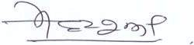

Mandira Sharma
Executive Director, Advocacy Forum

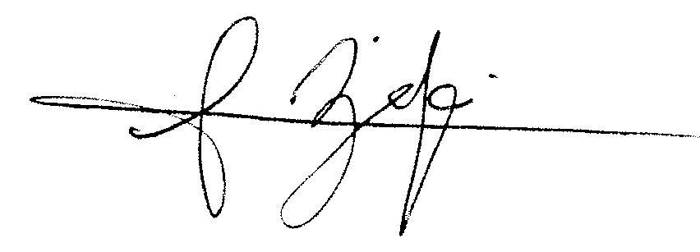

Sam Zarifi,
Asia-Pacific Programme Director
Amnesty International

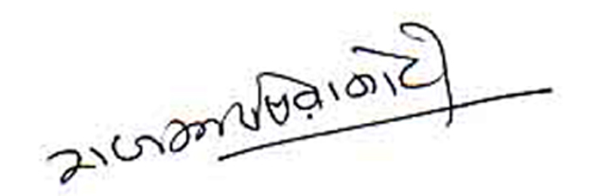

Raj Kumar Siwakoti
Secretary General, Human Rights and Democratic Forum (FOHRID)

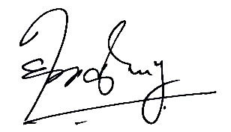

Hom Kanta Chaulagai
Chairperson, Human Rights and Peace Society (HURPES)
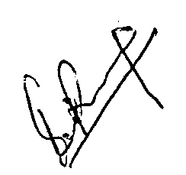

Subodh Raj Pyakurel
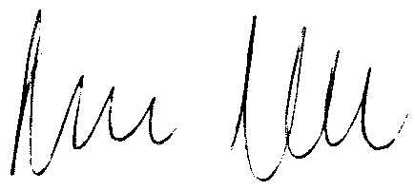
Chairperson, Informal Sector Service Centre (INSEC)

Roger Normand
Director, Asia Pacific Program, International Commission of Jurists (ICJ)

